Step-by-Step Process to Complete the Task

Step 1: Access Jenkins
- Click on the Jenkins button from the top bar.
- Log in using:
  - Username: admin
  - Password: Adm1n321
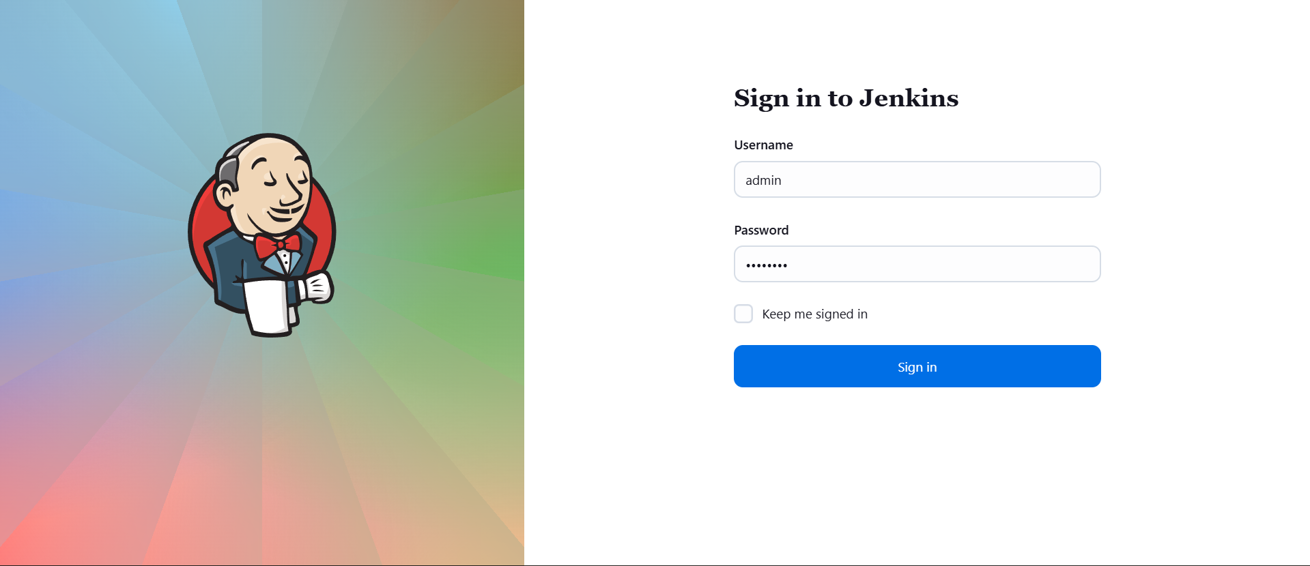

Step 2: Install Required Jenkins Plugins
- Navigate to Manage Jenkins → Plugins → Available plugins.
- Search and install the following plugins:
  - Git
  - Pipeline
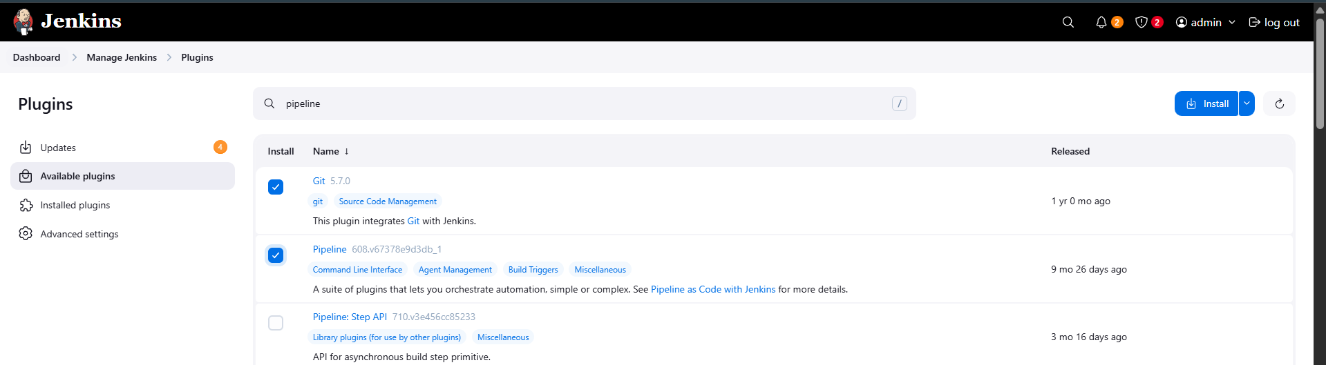
- After installation, click Restart Jenkins when installation is complete and no jobs are running.
- Refresh the UI after Jenkins restarts.

Step 3: Configure Jenkins Credentials

3.1 Git (Gitea) Credentials
- Go to Manage Jenkins → Credentials → System → Global credentials (unrestricted).
- Click Add Credentials.
- Set:
  - Kind: Username with password
  - Username: sarah
  - Password: Sarah_pass123
  - ID: sarah-git-creds
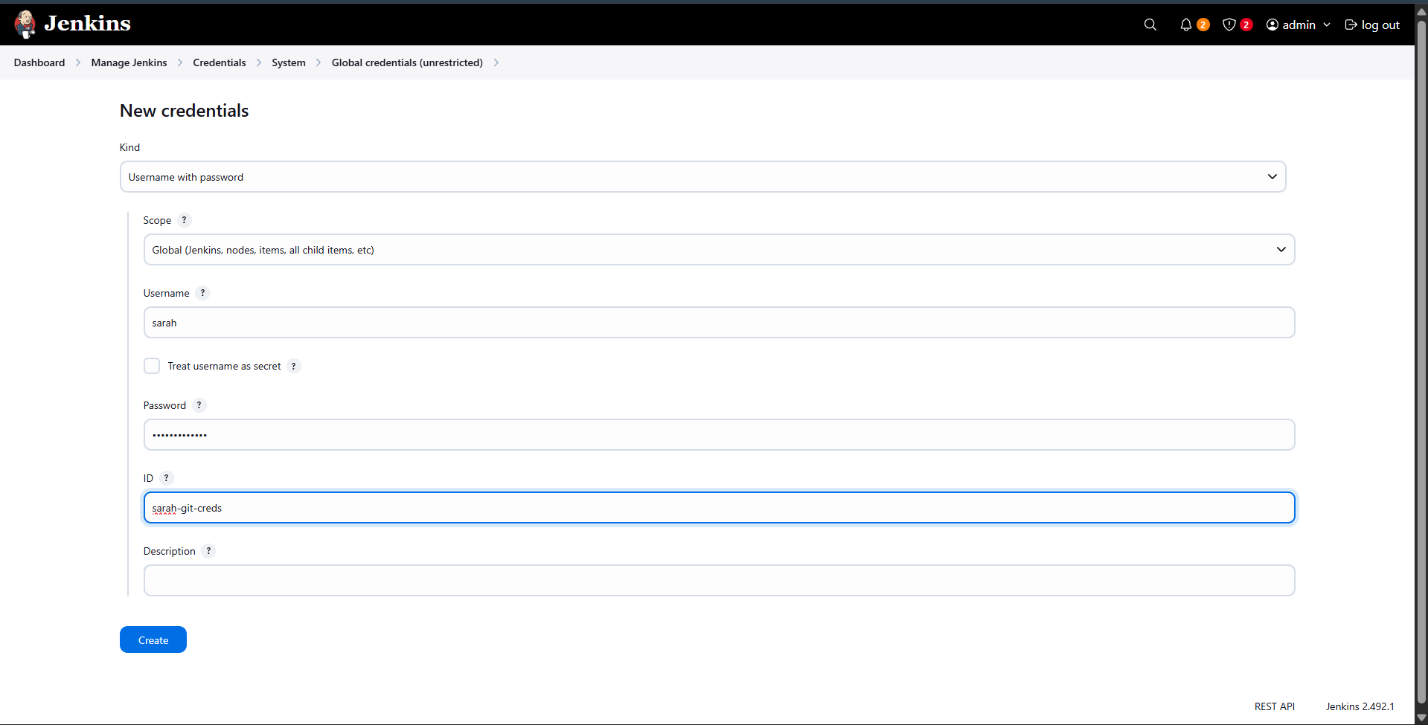
- Click Create.

3.2 Storage Server SSH Credentials
- Again, click Add Credentials.
- Set:
  - Kind: Username with password
  - Username: natasha
  - Password: (as provided in the lab)
  - ID: ssh-storage-server
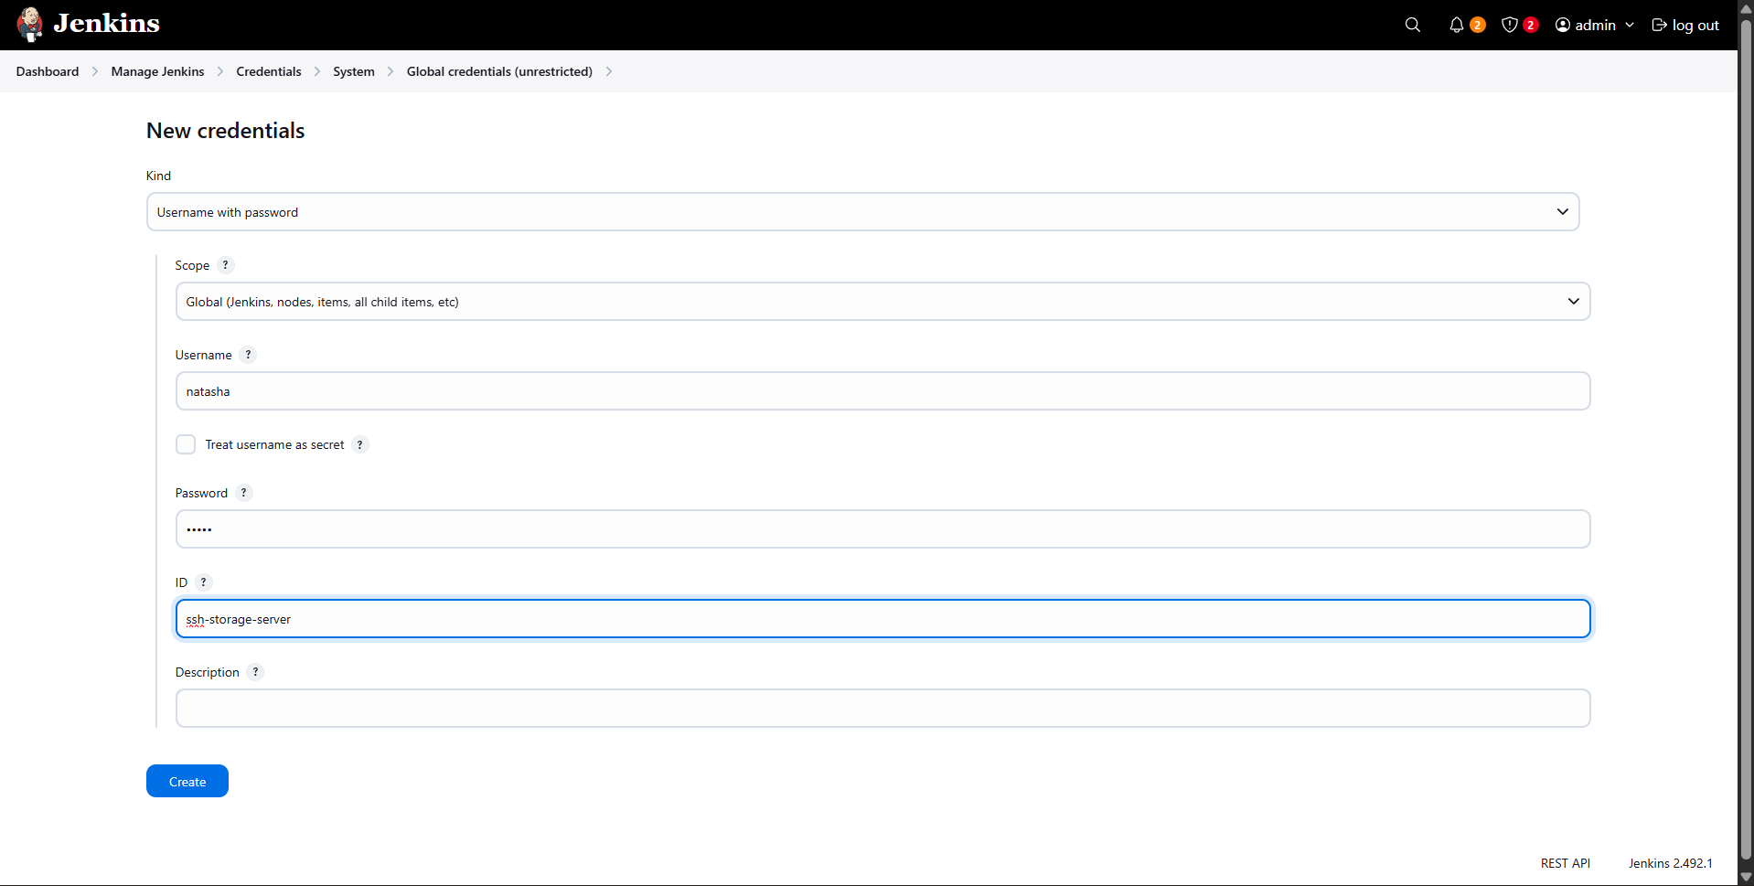
- Click Create.

Step 4: Update Website Content in Gitea
- Click on the Gitea button from the top bar.
- Log in using:
  - Username: sarah
  - Password: Sarah_pass123
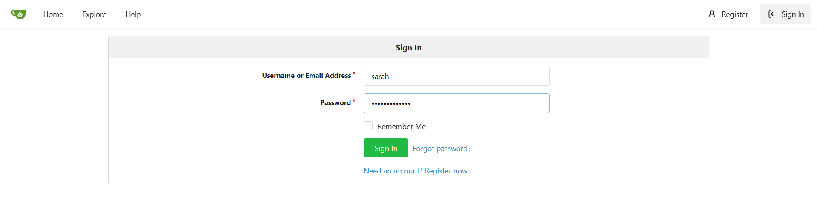
- Open the repository:
sarah/web
- Edit the file index.html.
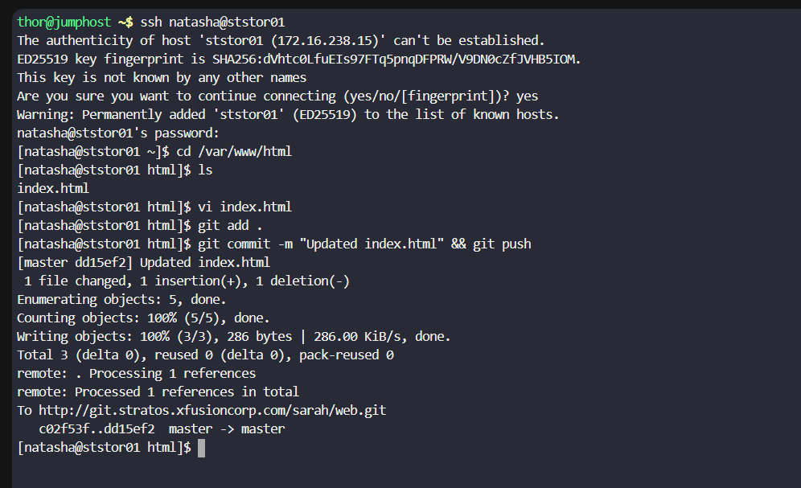
- Update the content to:
- Welcome to xFusionCorp Industries
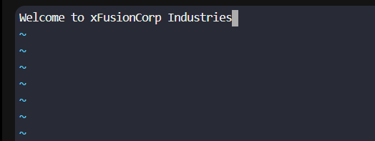
- Commit the changes directly to the master branch.

Step 5: Create Jenkins Pipeline Job
- In Jenkins Dashboard, click New Item.
- Enter job name:
deploy-job
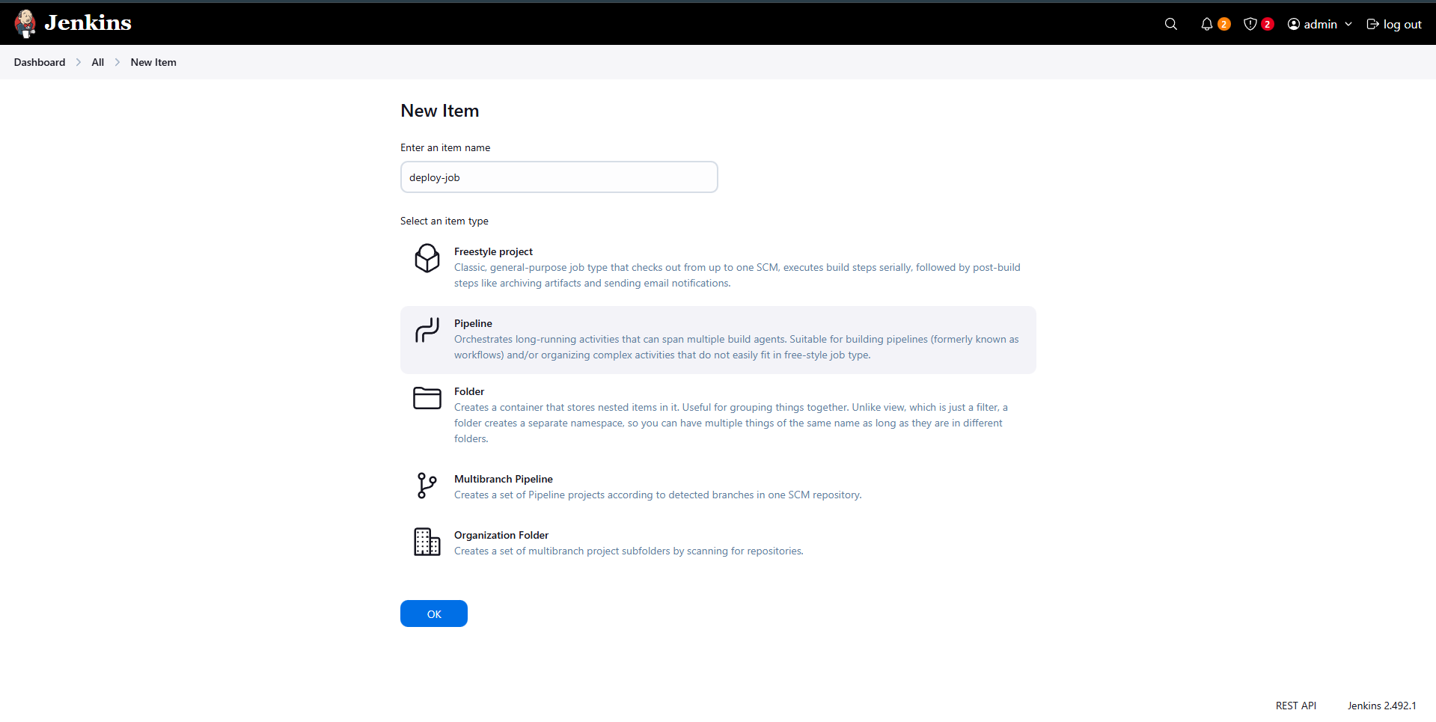
- Select Pipeline (do NOT select Multibranch Pipeline).
- Click OK.

Step 6: Configure Pipeline Script
- Scroll to the Pipeline section.
- Choose Pipeline script.
- Add a pipeline with two stages only (names are case-sensitive):
  - Deploy
  - Test
- Deploy stage
  - Clone the sarah/web repository from the master branch.
  - Copy index.html to /var/www/html/ on the Storage Server.
  - This directory is already mounted on all App Servers.
- Test stage
  - Verify the website is accessible using:
  - curl -f http://stlb01:8091
  - The stage must fail if the site is not accessible or if Deploy fails.
Pipeline:
pipeline {
agent any

stages {
stage('Deploy') {
steps {
git branch: 'master',
credentialsId: 'sarah-git-creds',
url: 'http://git.stratos.xfusioncorp.com/sarah/web.git'

withCredentials([usernamePassword(credentialsId: 'ssh-storage-server',
usernameVariable: 'SSH_USER',
passwordVariable: 'SSH_PASS')]) {

sh '''
sshpass -p "$SSH_PASS" scp -o StrictHostKeyChecking=no \
index.html $SSH_USER@ststor01:/var/www/html/
'''
}
}
}

stage('Test') {
steps {
echo 'Testing Application ...'
sh 'curl -f http://stlb01:8091'
}
}
}
}
- Save the job.

Step 7: Run the Pipeline
- Click Build Now on deploy-job.
- Ensure:
  - Deploy stage completes successfully.
  - Test stage passes without errors.
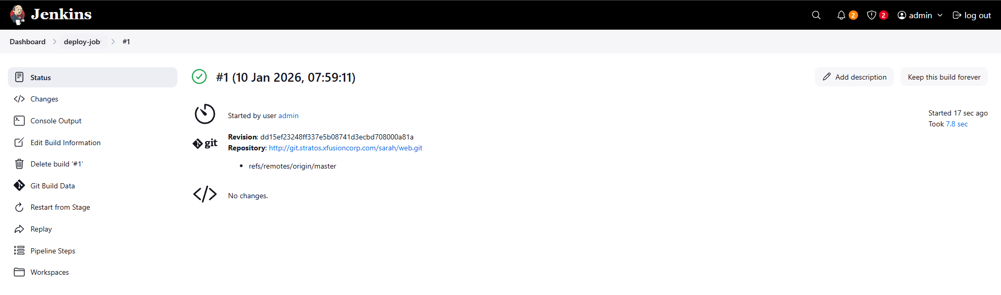
- Build status should be SUCCESS (green check).

Step 8: Validate Deployment
- Click the App button from the top bar.
- Open the URL:
- http://stlb01:8091
- Confirm:
  - Page loads successfully.
  - Content displays:
  - Welcome to xFusionCorp Industries
  - No sub-directory is used (not /web).
